**Mini Project – 2**

**Amazon Web Services**

**LAB 1**

**Setup the MFA for root user.**

1. **Login your aws root account**

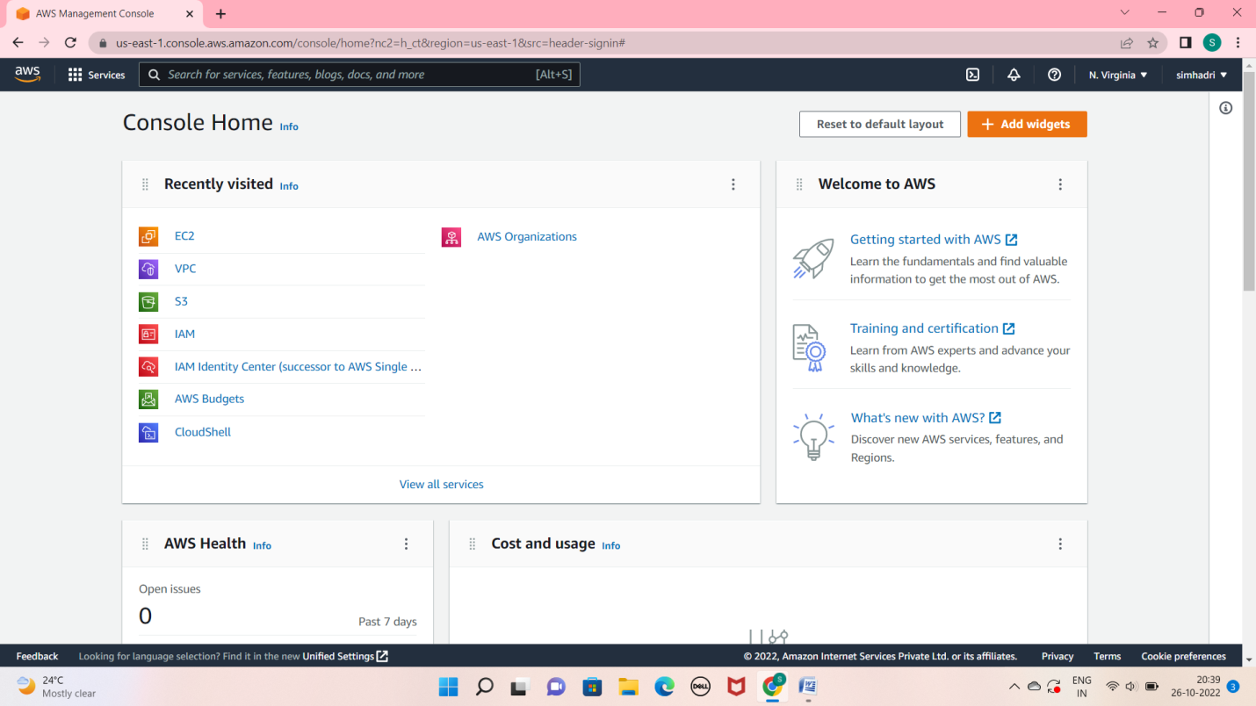

1. **Click on the profile Name and goto security credential.**

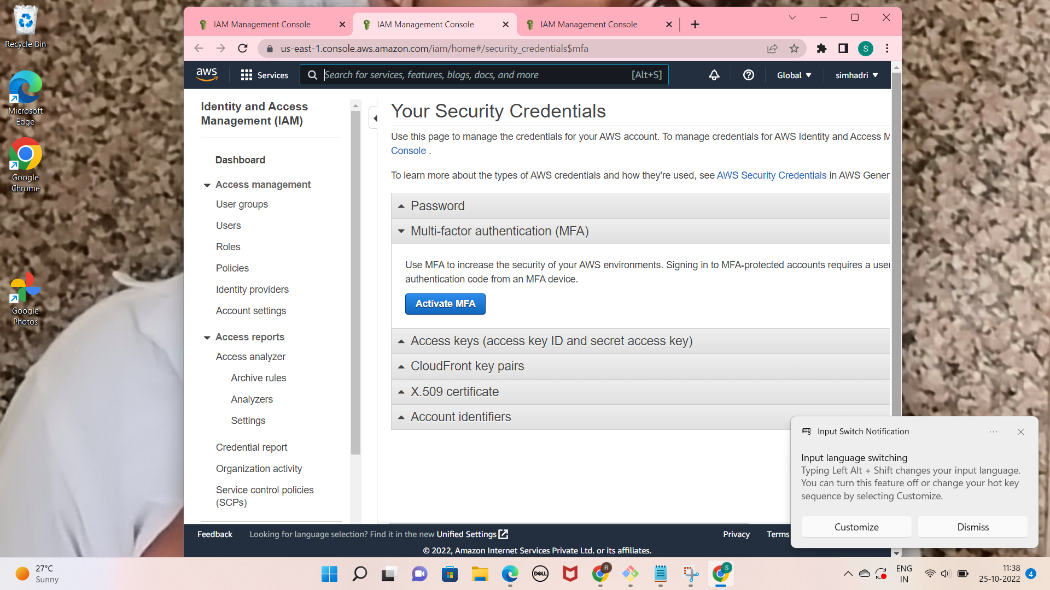

**3. click on the activate MFA**

**and there is 3 option for activating MFA we can select anyone i am selecting virtual MFA device**

**Because i want to activate through mobile app we can use any authenticator app i am using google authenticator for activating MFA. and open your mobile and scan this QR code**

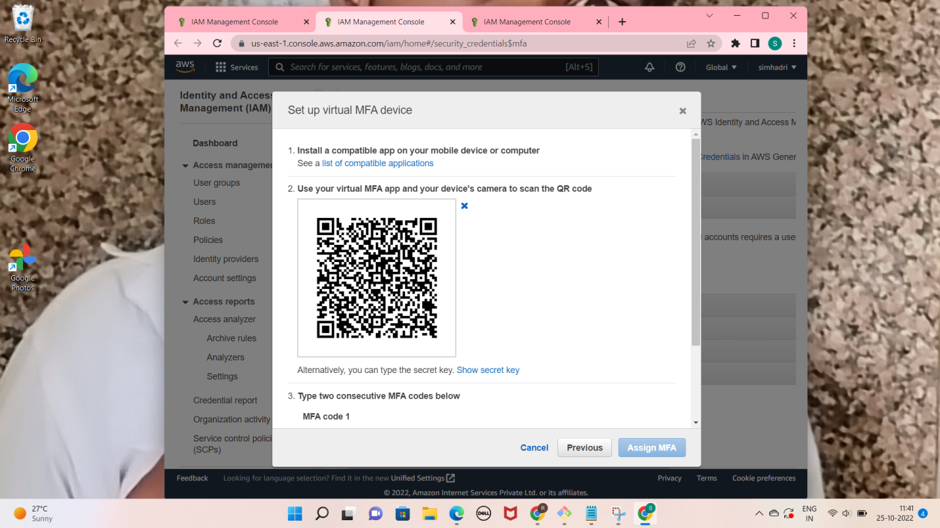

**type 2 security code**

**after that click on asign MFA**



**Now MFA is Activated in root account.**

**Lab 1 Q2 . Create a new user with console access and check its default permissions.**

**Cearch IAM service in consol searchbox and click on it after that click on user**

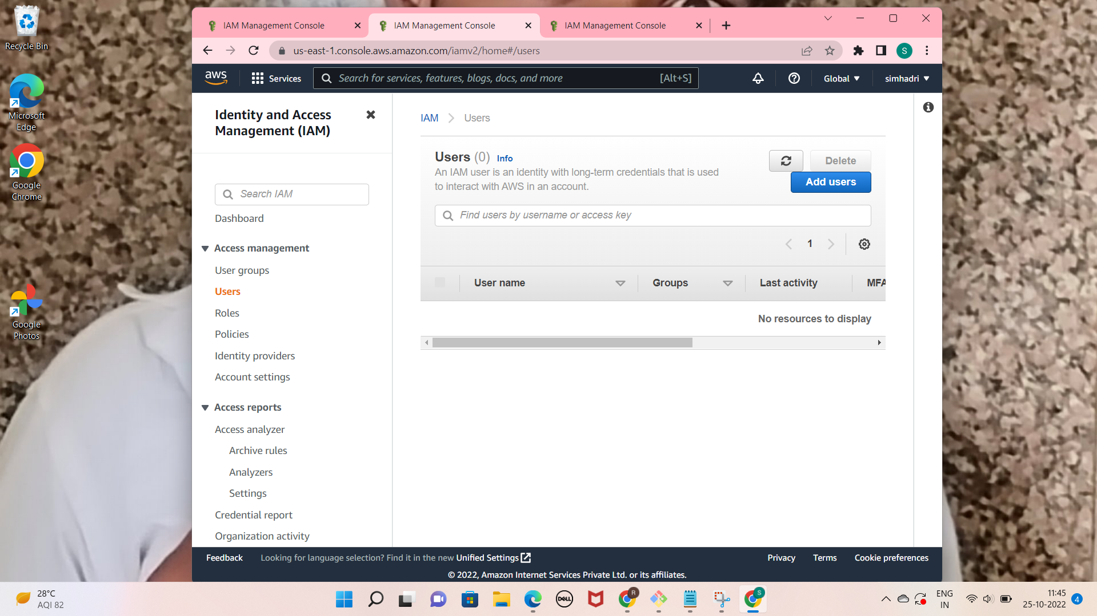

**Click add user**

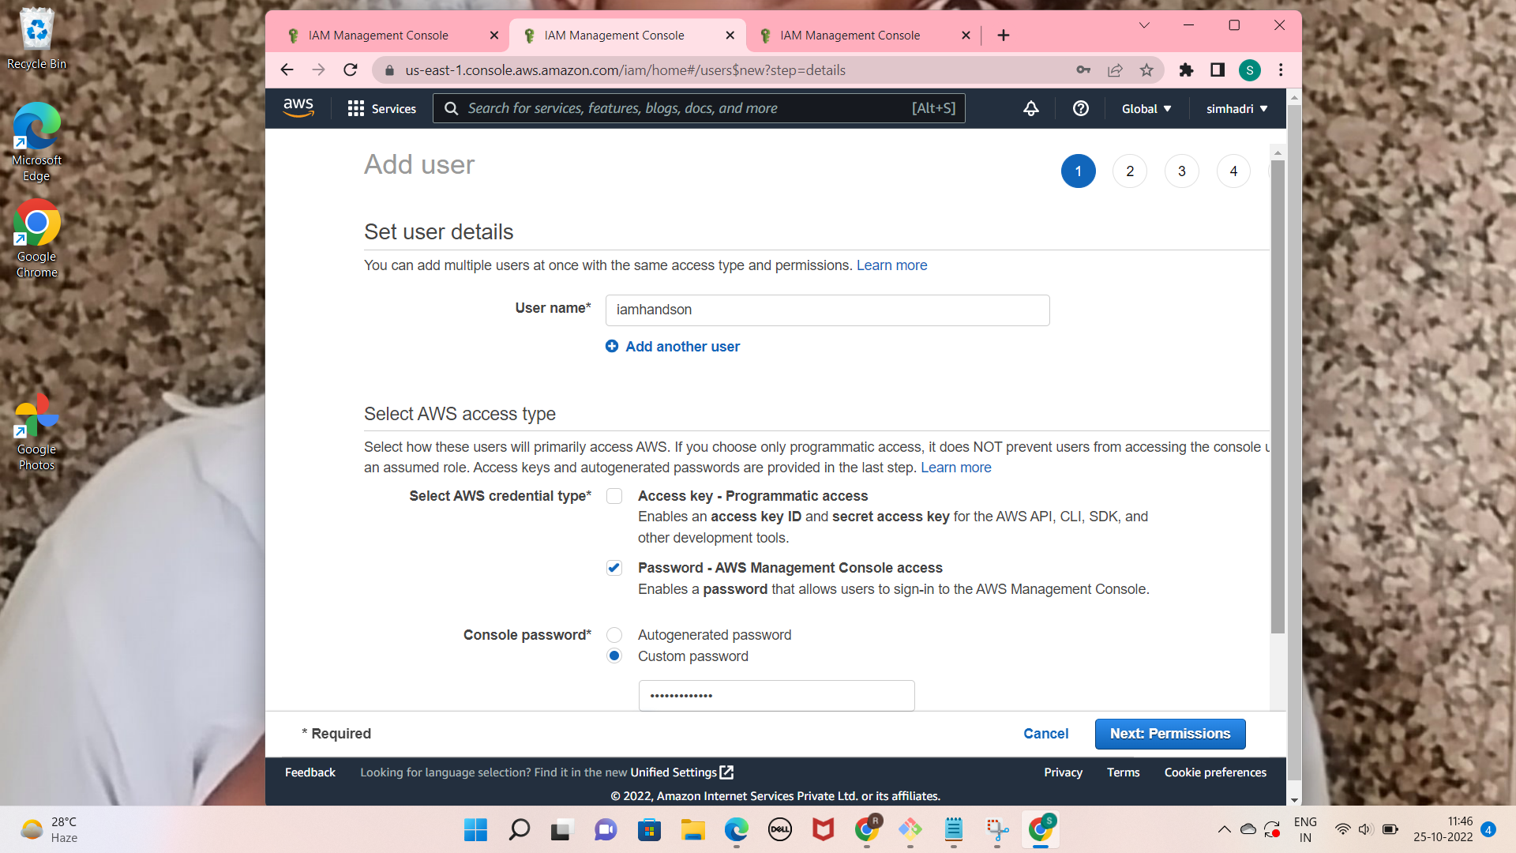

**with new IAM account there is no any default permission after login we are not able to access any services.**

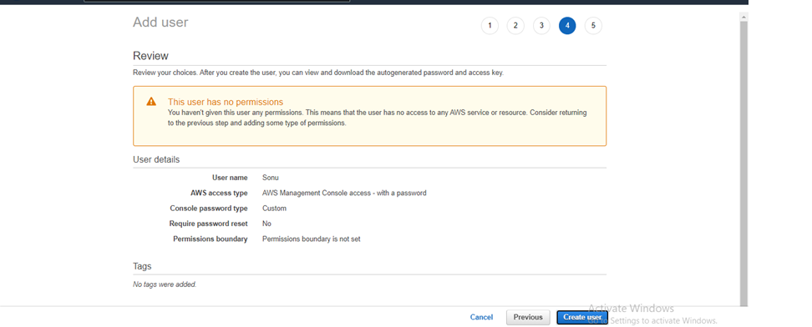

**Lab 1 Q3- Assign Only EC2 full permissions to this user and navigate to different services with this user account, check if you can work with any other service except EC2.**

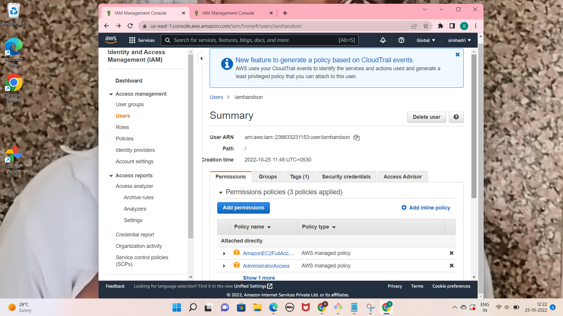

**Added the ec2 full permission with IAM user Now i am able to access EC2**

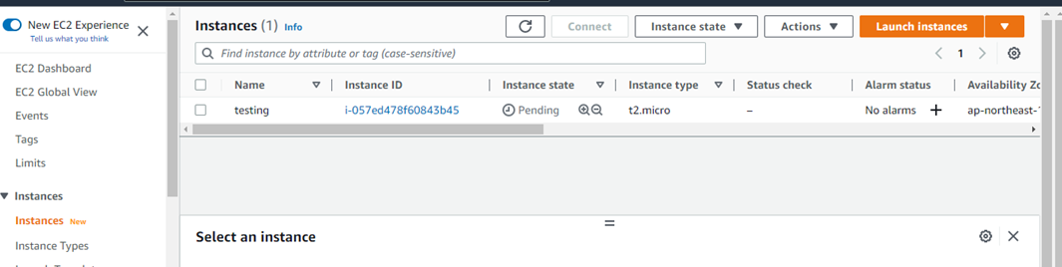

**I am not able to access other services from this IAM user**

**Because of Permission**

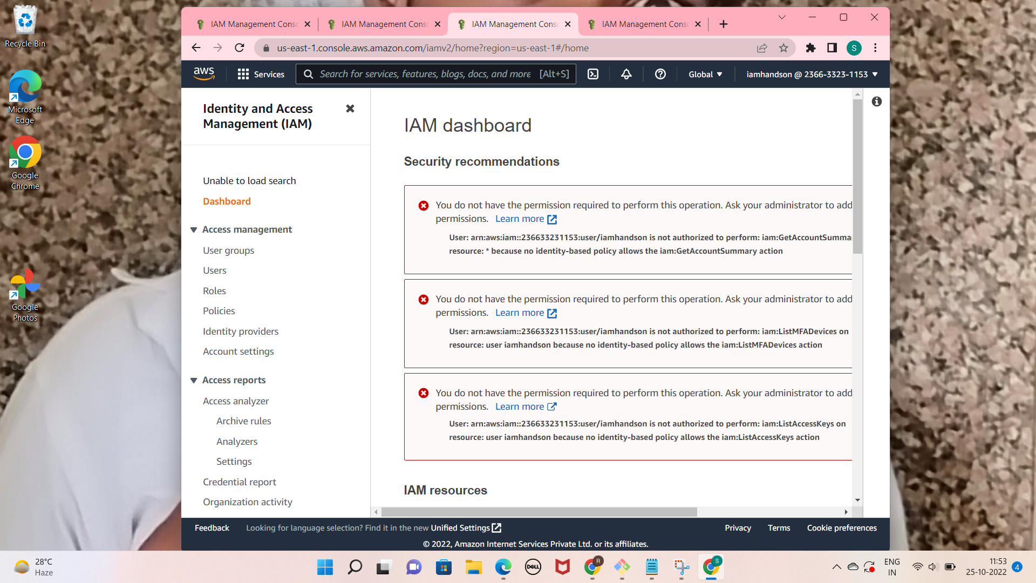

**Lab 1 Q4 . Provide the Administrative privileges to this user.**

**I added Administrator Permission in this IAM user**



**After Adding the administrator permission i am able to access all resourses like root account.**

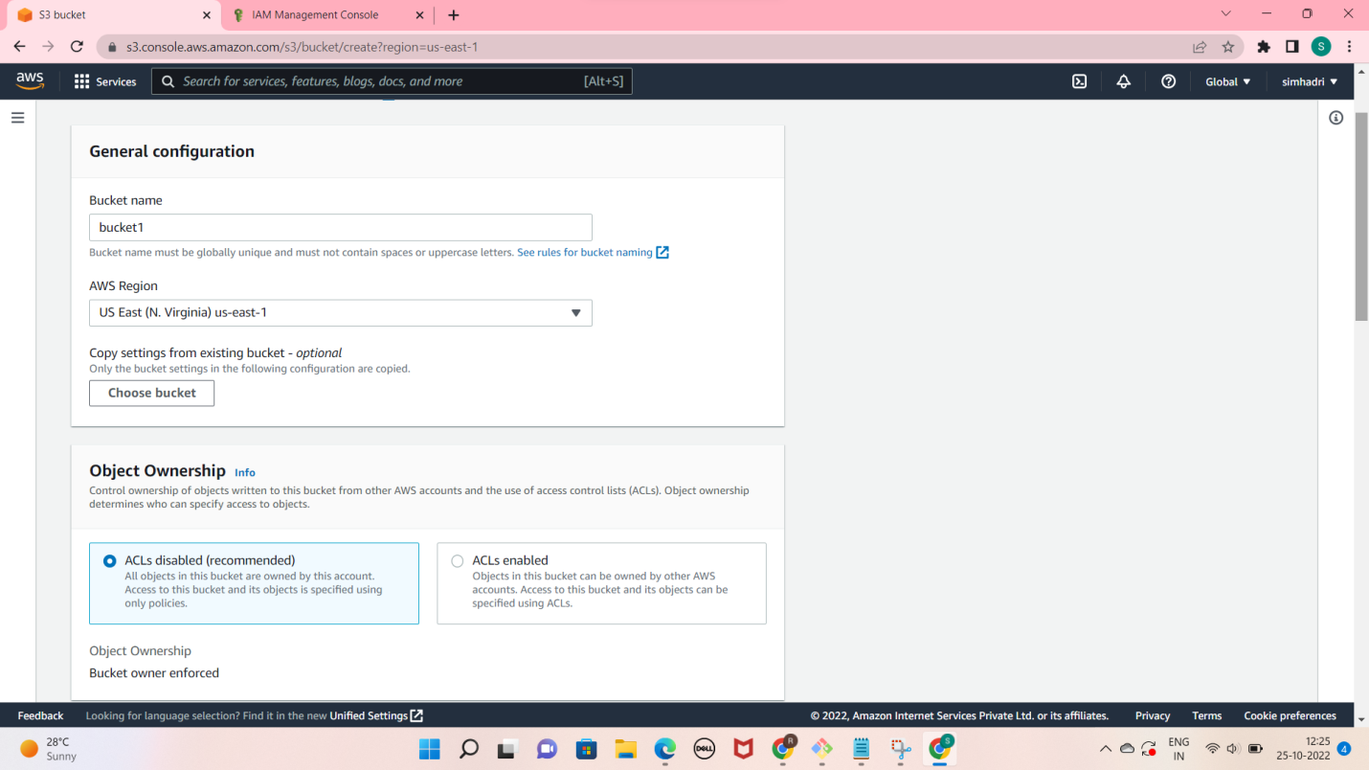

**LAB 3**

Create an S3 bucket, make sureStToEgPiv1e: it a unique name.

• Upload Some test files/folder in the bucket.

• Try to access the file over the browser using its URL. It

should give error.

• Check the permissions of the file and the bucket.

• Make the object public and access it again over the browser.

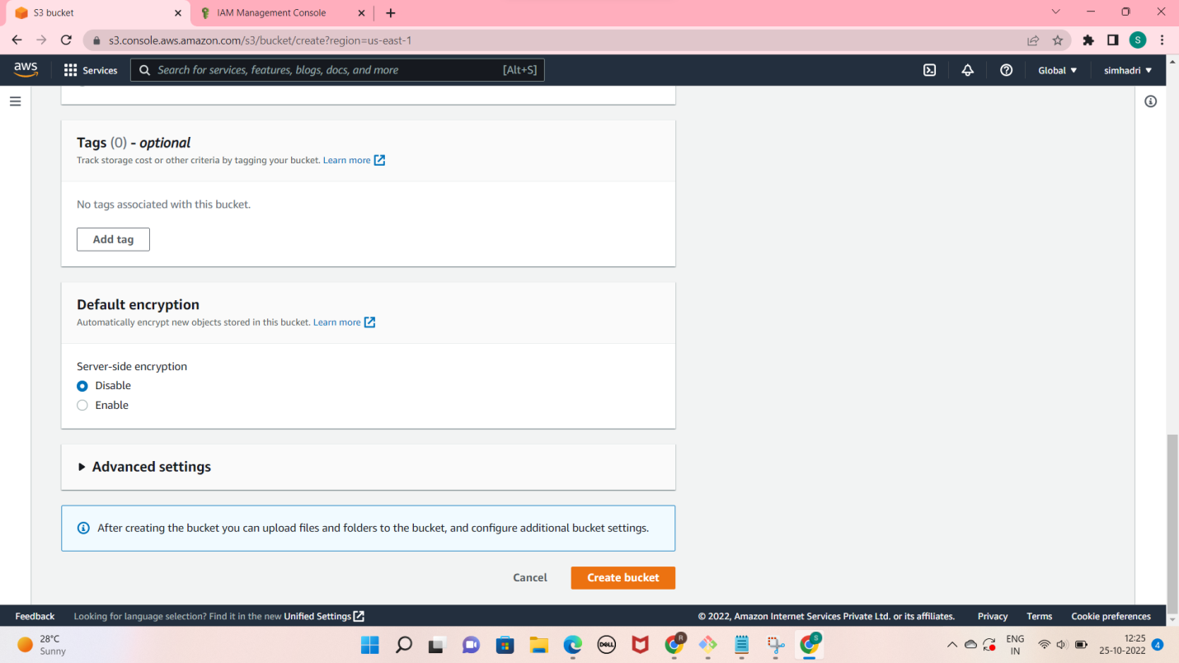

* **Uploaded the file in bucket**
* **Able to access this object**

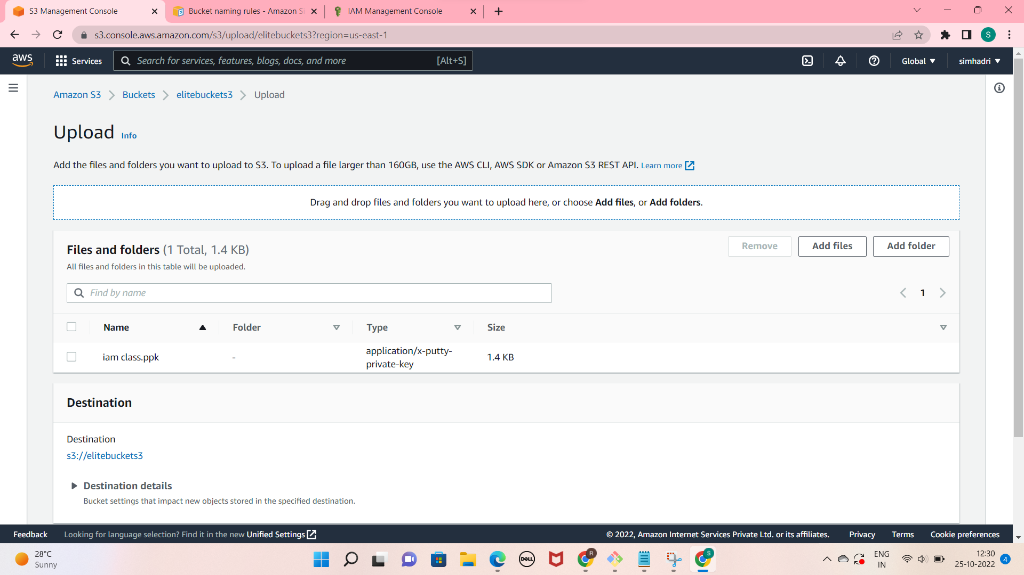

**STEP 2:**

**• Enable versioning of the bucket.**

**• Create a text file and upload it in the bucket.**

**• Update the text file and upload the updated version to t**

**the bucket.**

**• Check the content of current file and the previous version of text file**

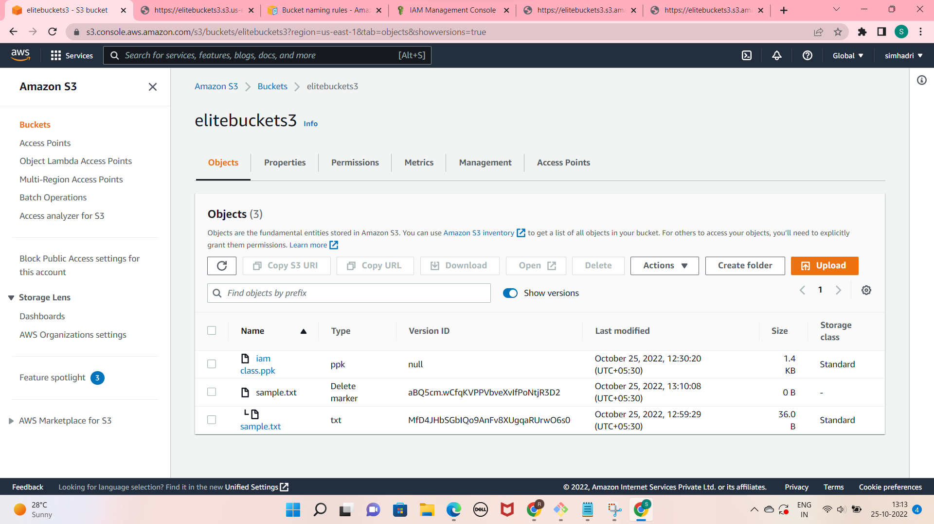

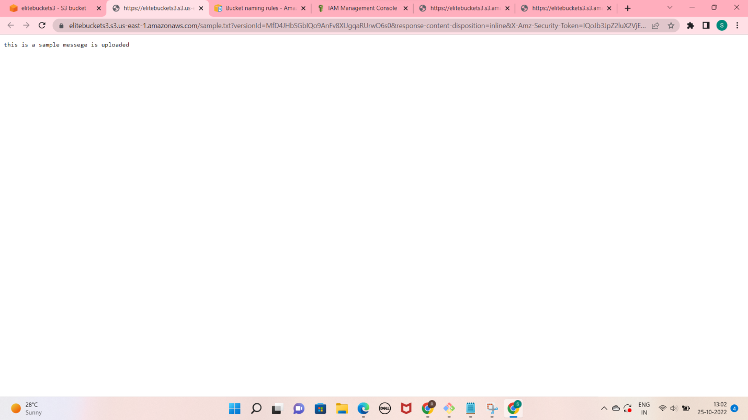

**STEP 3:**

**• Delete the text file from the bucket.**

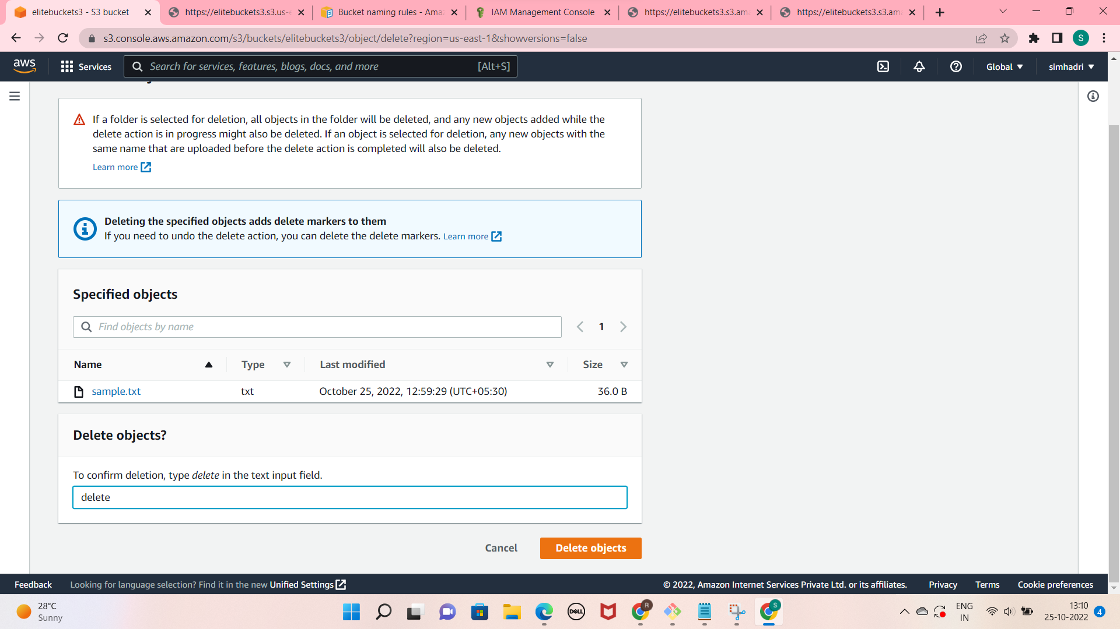

**Check and recover the deleted file from the versioning**

**turn the versioning and delete the marker type file then turn the the versioning.**



**LAB-4 EC2 Instance**

**• Launch one EC2 instance of type t2.micro with ubuntu OS**

**(free tier eligible).**

**• Allow the required port in the Security Groups so that you**

**can access it from outside.**

**• Access this instance from your local machine using putty/**

**other ssh software's.**

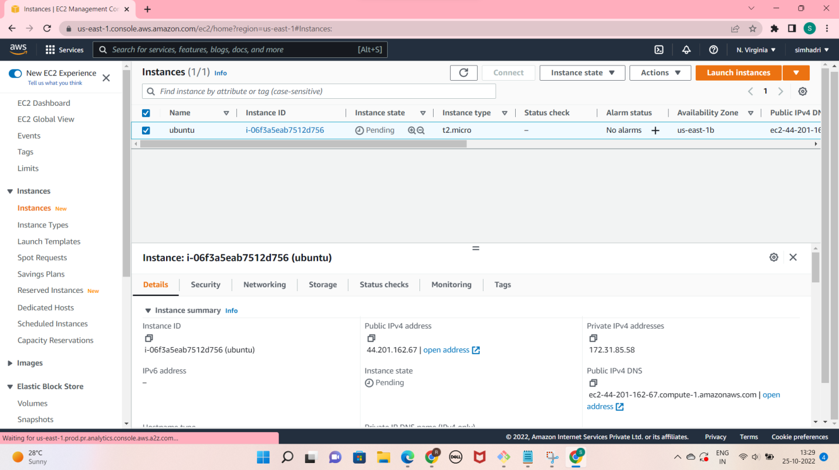

**Access this instance from your local machine using putty/**

**other ssh software's.**

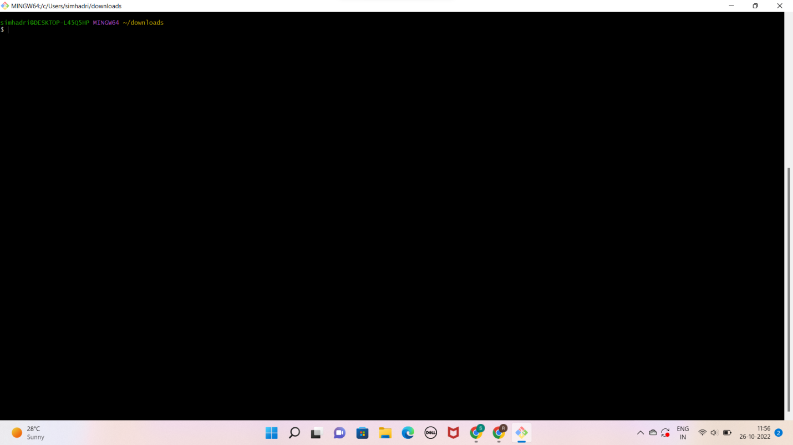

**LAB-5 Security Group**

**• Create a new security group and name it as “mynewSG”**

**• Check the default rules in this security group.**

**• Allow inbound port 80 and 22 from your IP address. Select a range**

**(IP/28) so that any changes in your dynamic IP will not impact the**

**rule.**

**• Attach this new SG to your existing EC2 Instance and try to access**

**the server now (SSH).**

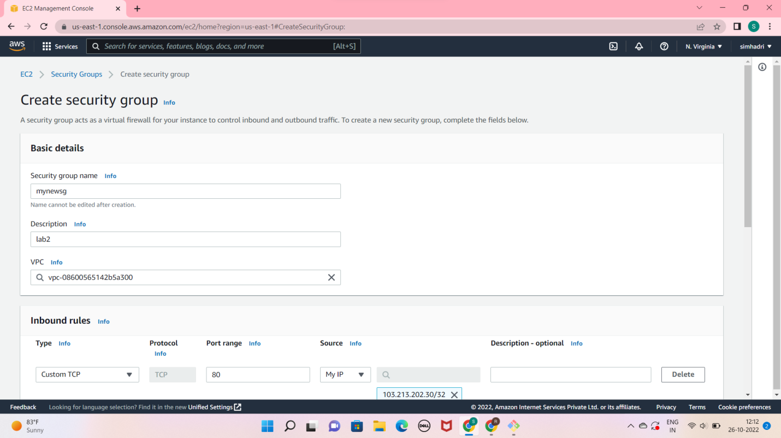

**its working with new security group**

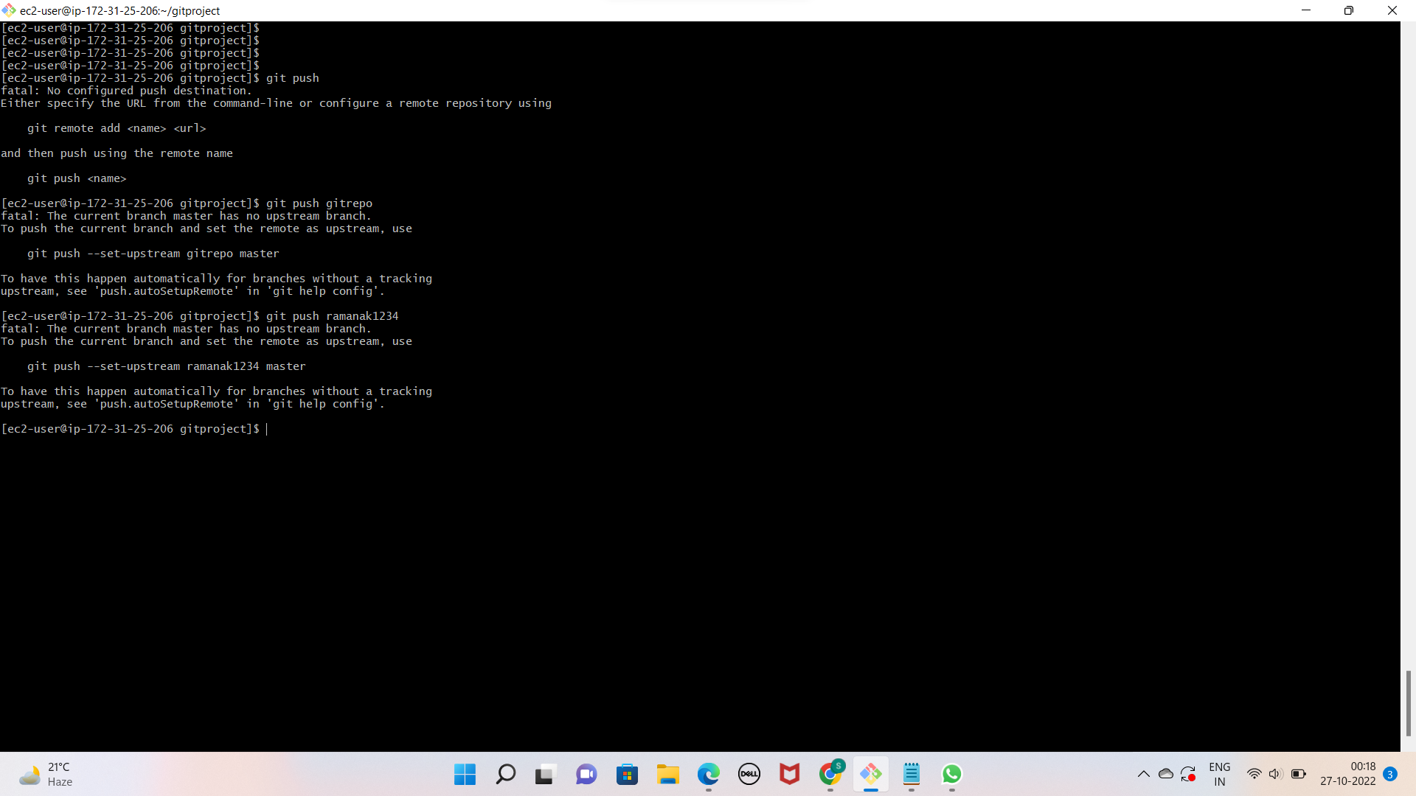

**LAB-6 Volumes and Snapshots**

**• Create one 5GB volume and attach it with the running EC2 Instance.**

**• Make sure this volume is available to use in Instance, take a**

**• reference from below link.**

**• Put some data in this volume like some testing files.**

**• Increase the size of this volume to 8GB and check it in the**

**Instance.**

**• Extend the size of this volume inside the Linux machine.**

**• Take a snapshot of this volume and delete it.**

**• Create a new volume with the snapshot and attach it to the server**

**just like the step 1.**

**Attaching the 5 gb volume with existing instance**

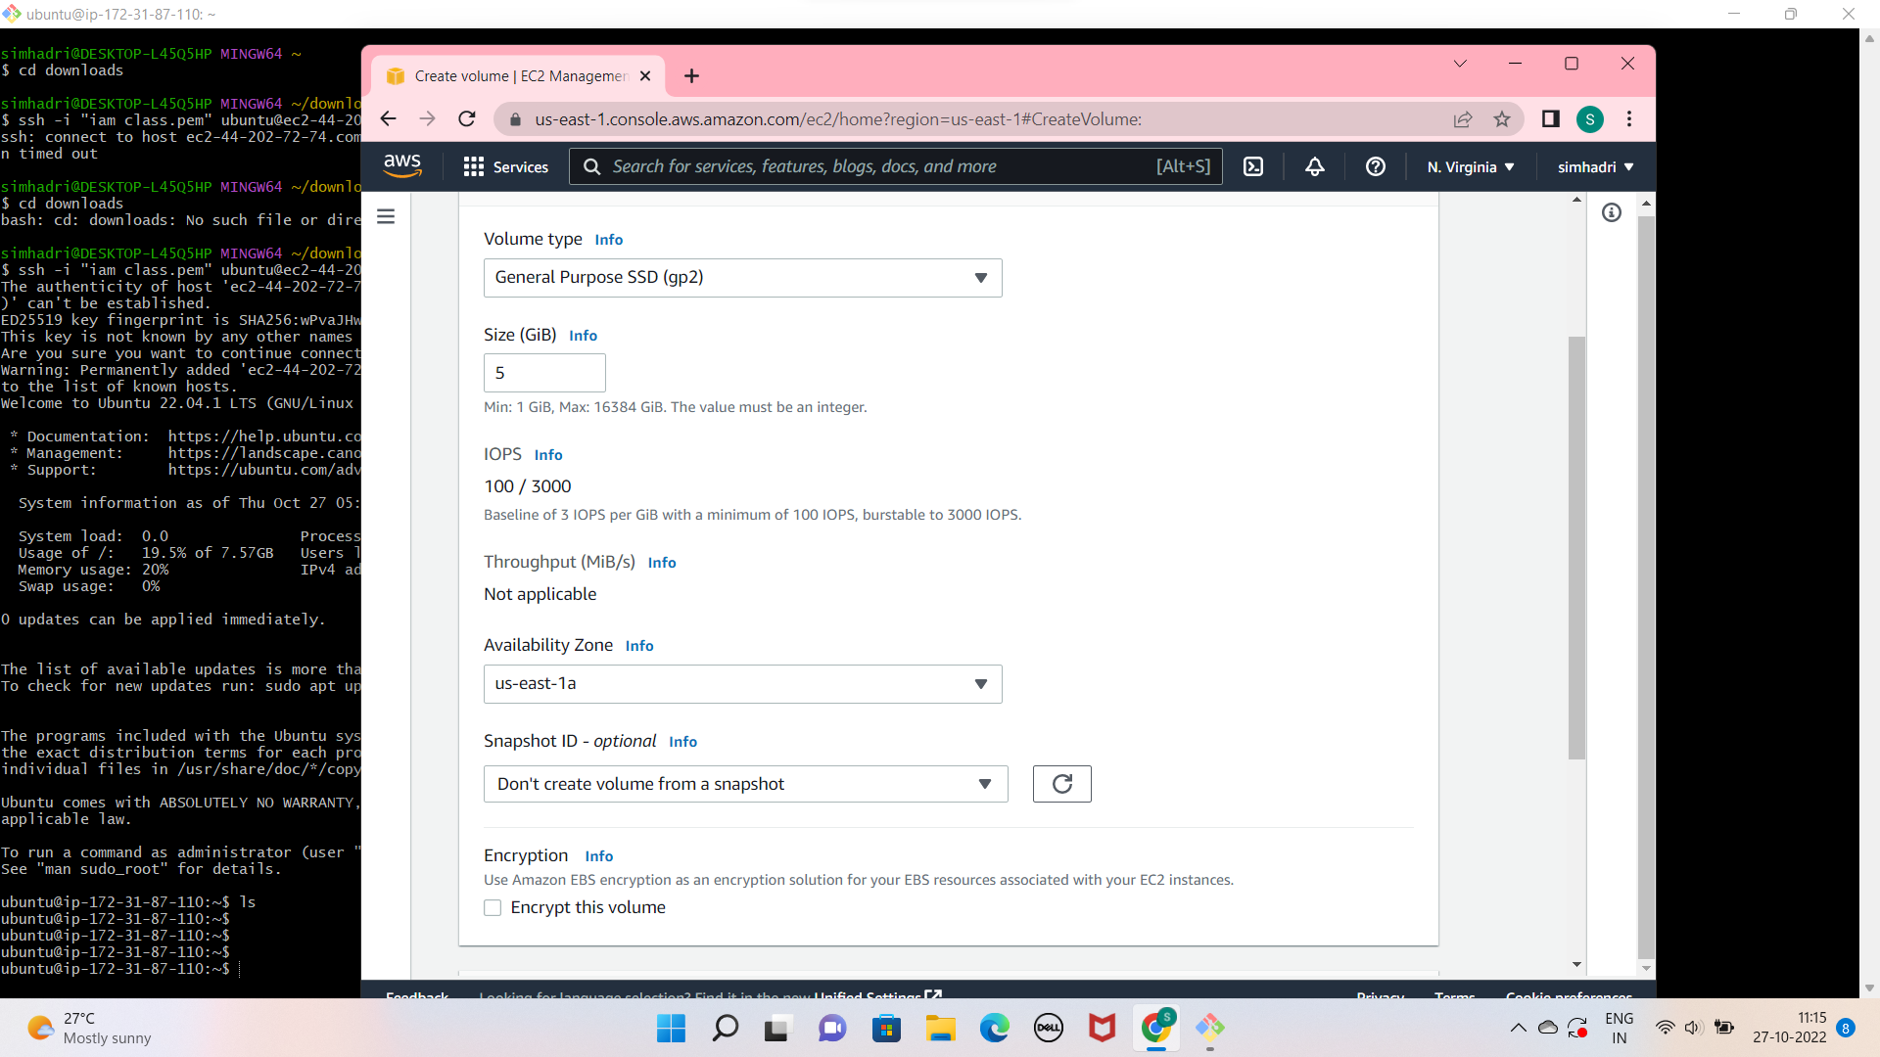

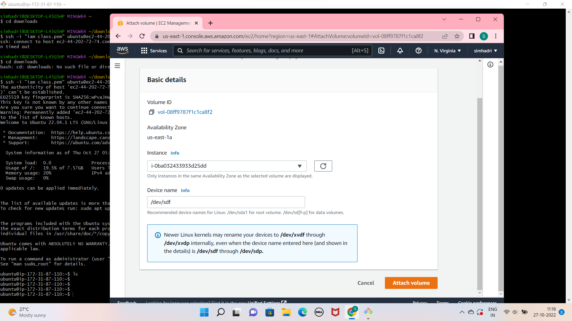

**Increase the size of this volume to 8GB and check it in the**

**Instance.**

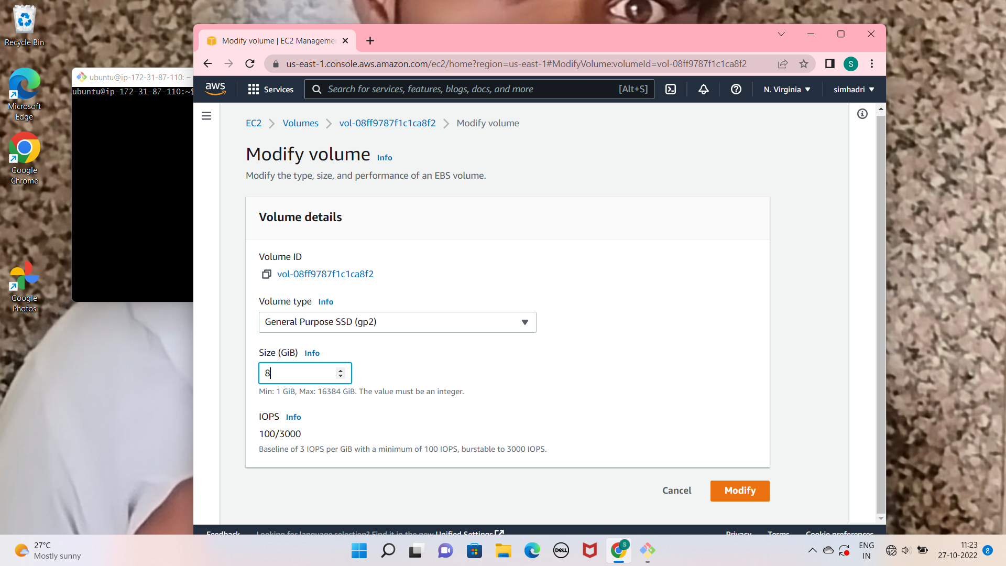

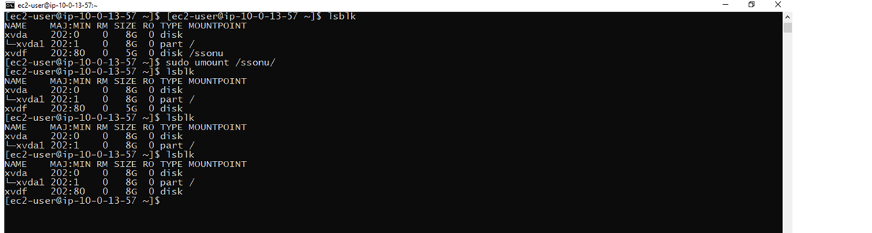

**Take a snapshot of this volume and delete it.**

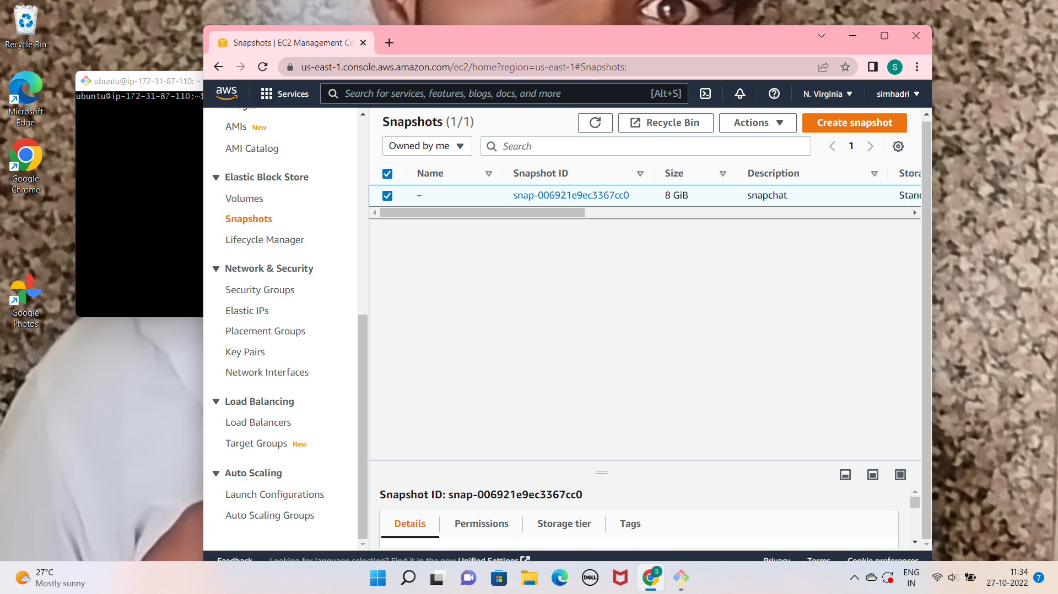

**LAB-7 AMIs**

**• Create an AMI of your Running Instance**

**1. Select Your Running Instance**

**2. Click on Action on the top right**

**3. Select image and templates and click on create image**

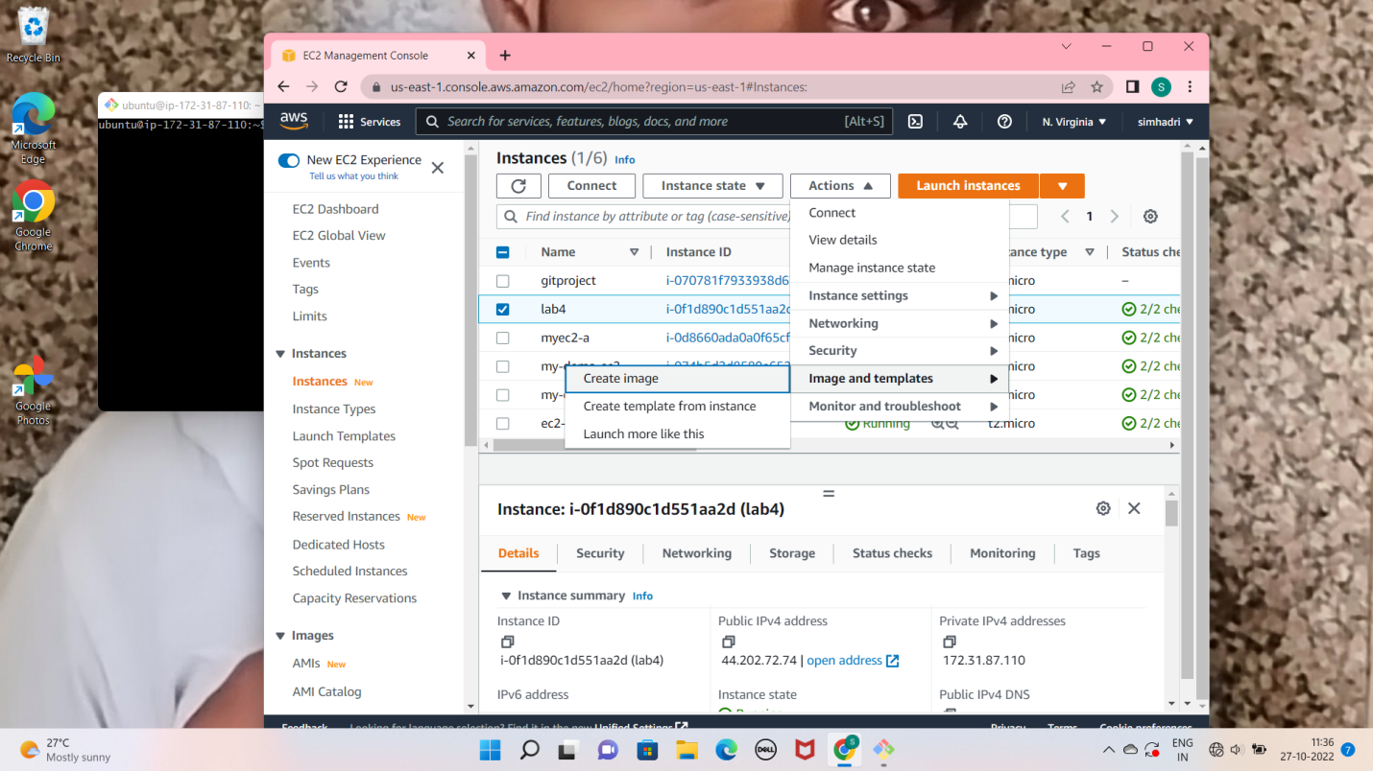

**type image name choose volume size click on create image**

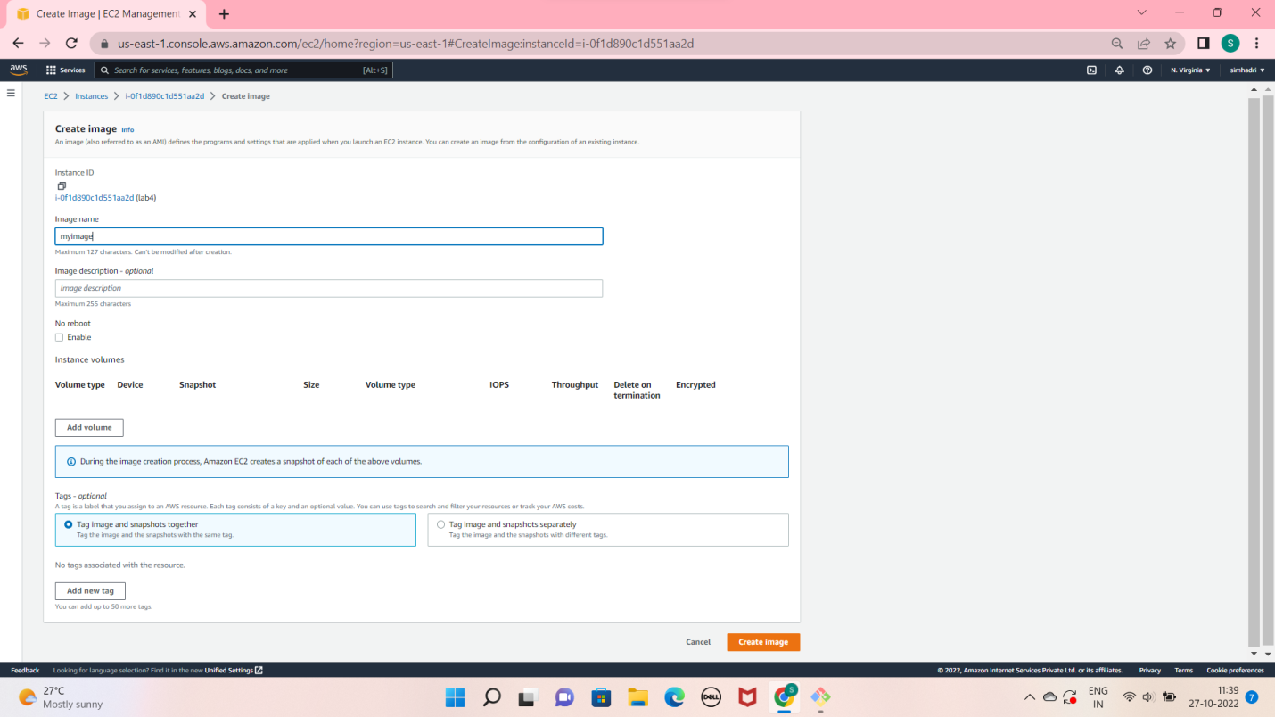

**LAB-8 Load Balancers**

**• Access both the servers over browser and check if their web page is visible.**

**• Allow only port 80 in LB security group and also make the SG of your instances to receive request from load balancer only on port 80.**

**• Create two EC2 instances and Install nginx server on one machine and apache server on server2.**

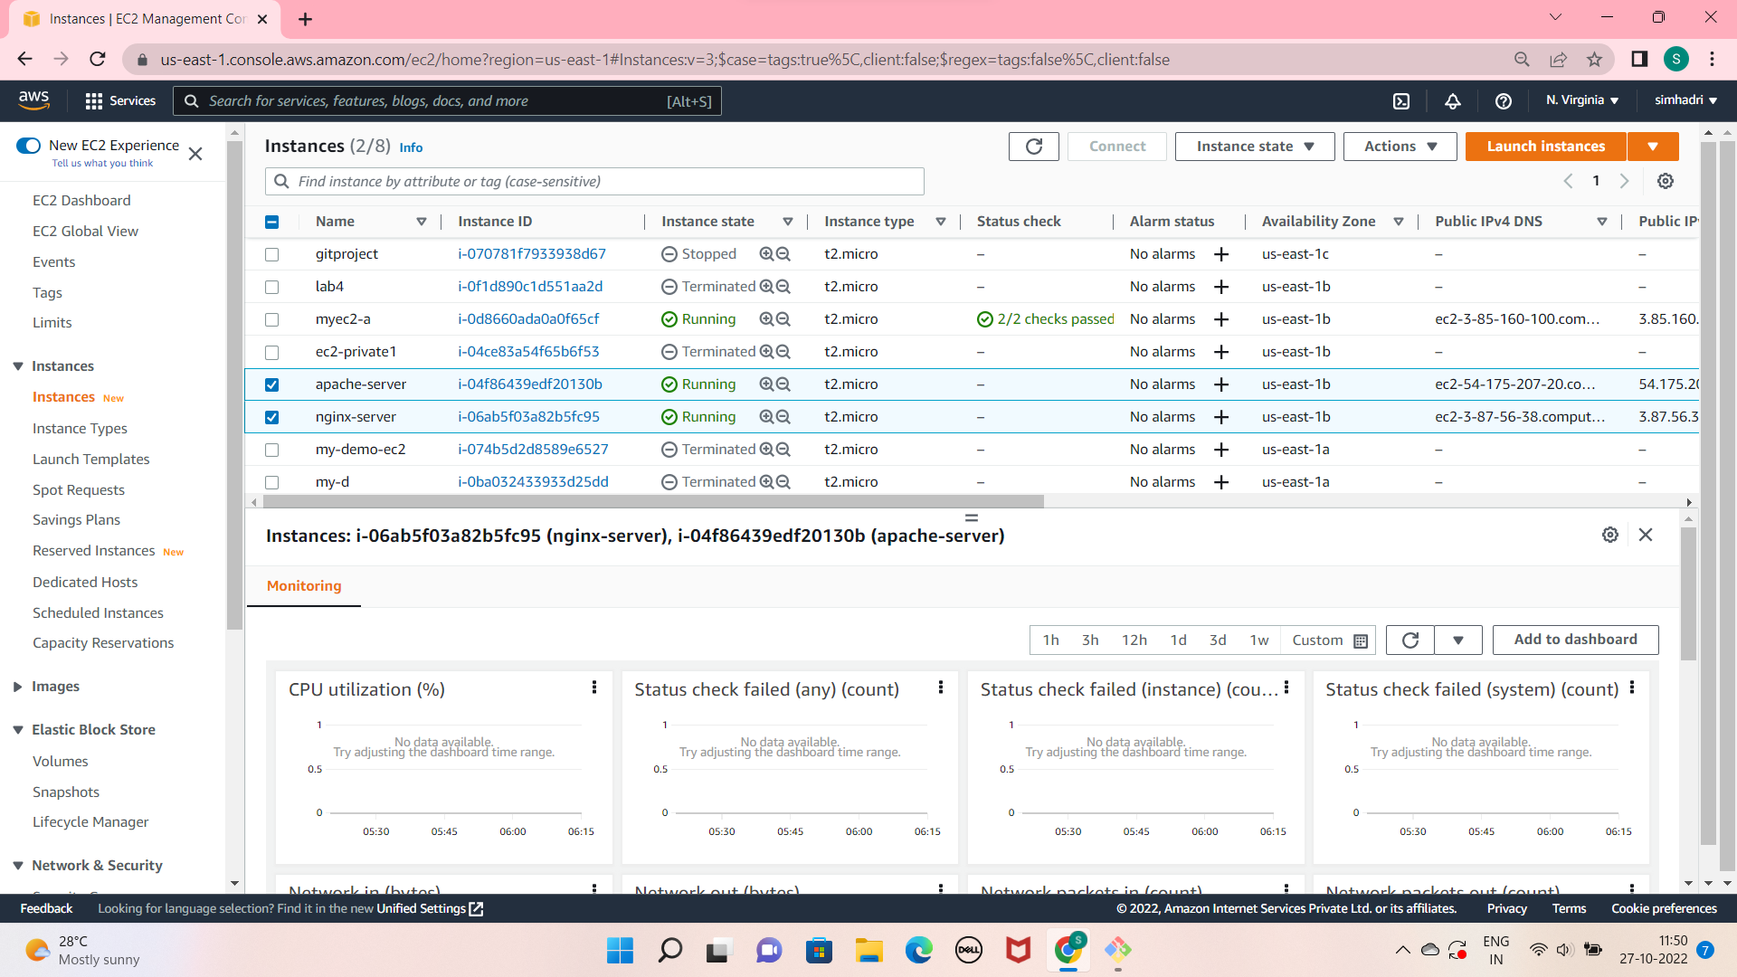

**Create one load balancer (application/Classic) and attach both the instances with the load balancer**

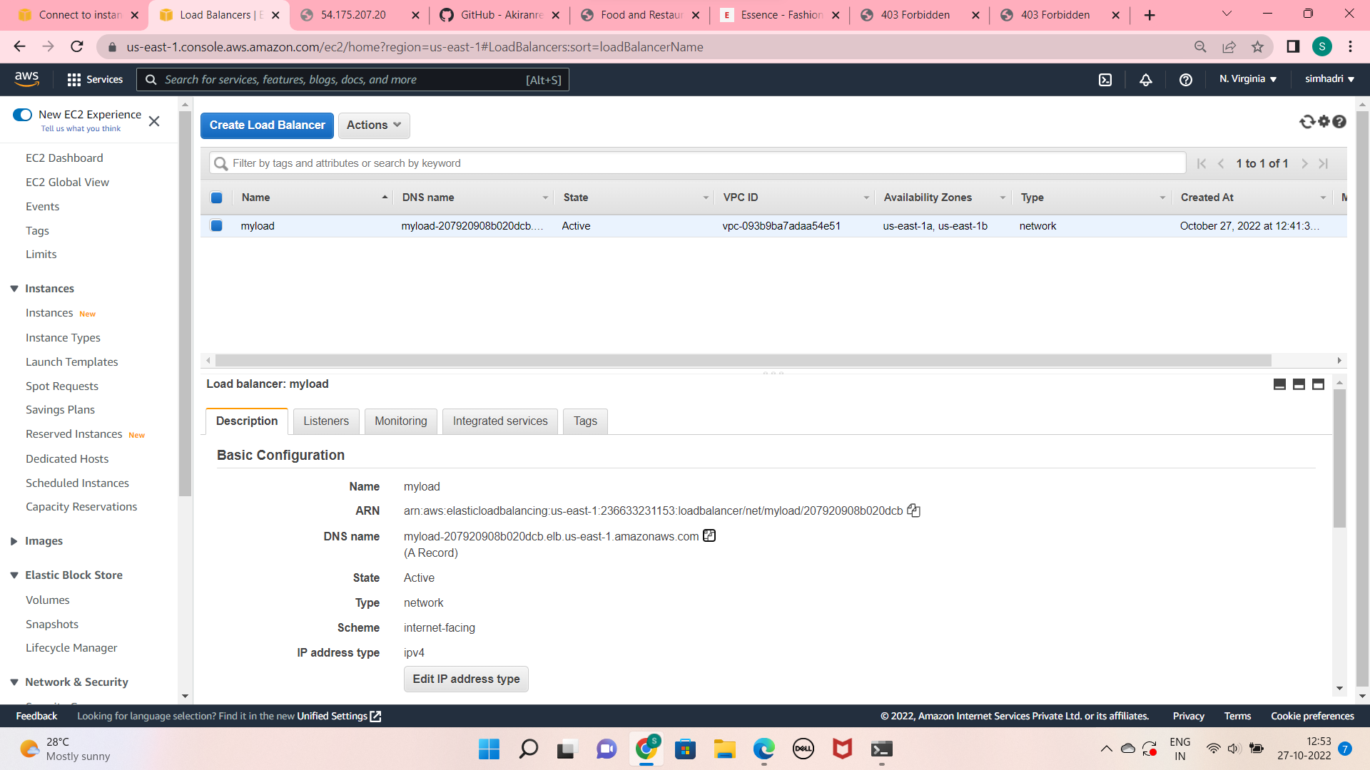

**• Access the load balancer link over the browser and hit it a couple oftimes. Check if both the webpages (nginx/apache are visible alternatively)**

**LAB-9 ASG and LC**

**Create one launch configuration with ubuntu server**

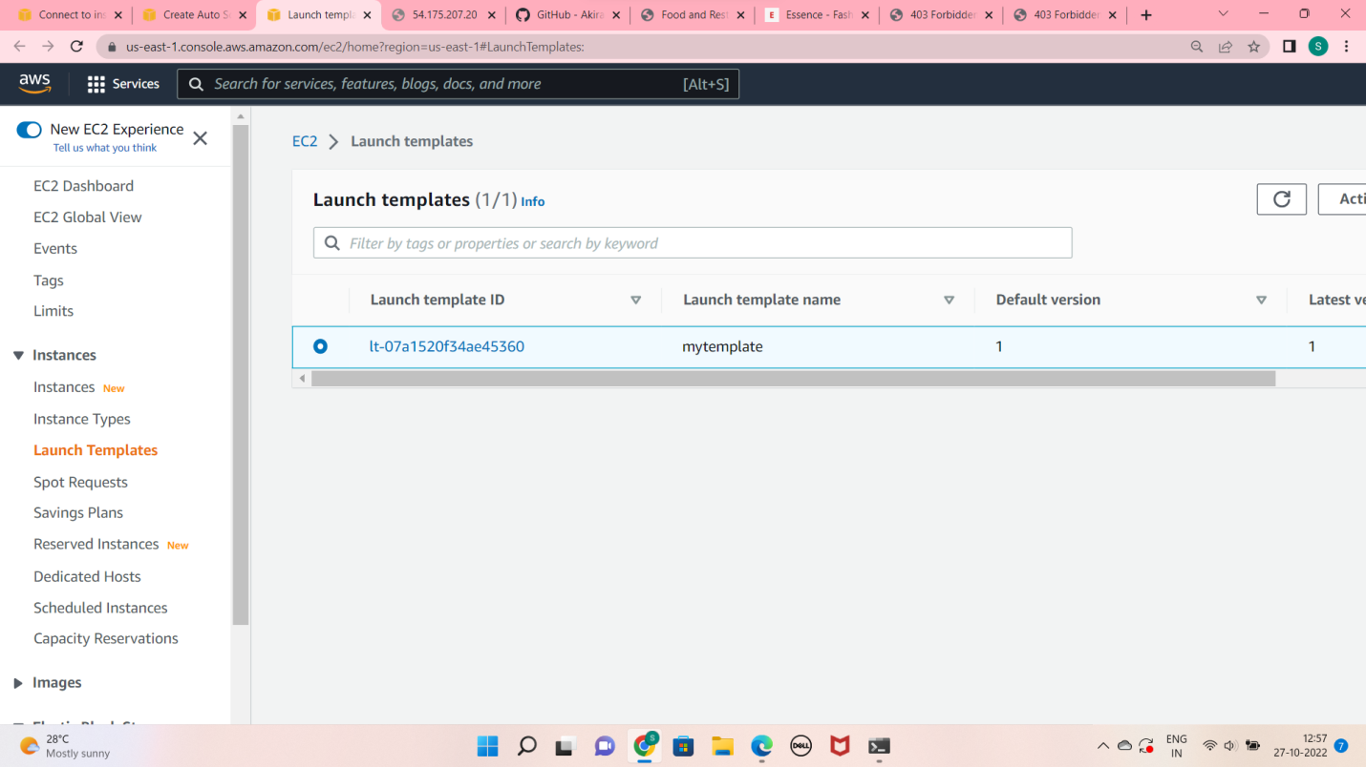

**• Create an auto scaling group and attach the above created launch configuration with it**

**• Keep the size of instances as Min=1 Max=3**

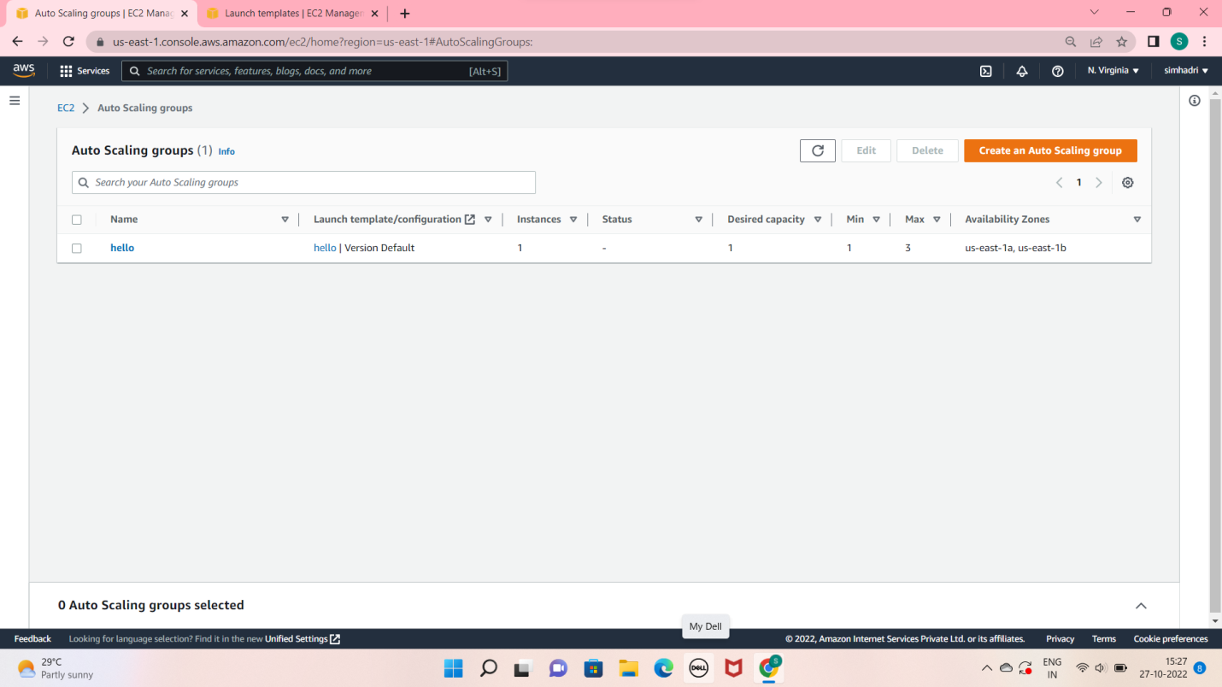

**• Try to change the max capacity and see the new instance should get created**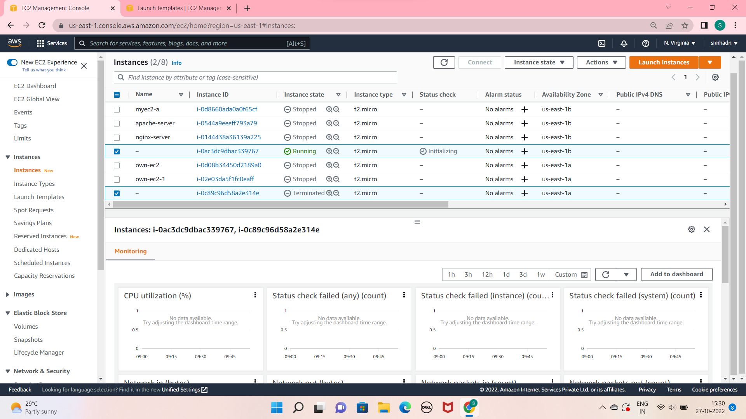

**LAB-10 RDS**

**• Provision an RDS instance.**

**• Open MySQL Port in the connected SG.**

**• Access this RDS from your EC2 instance**

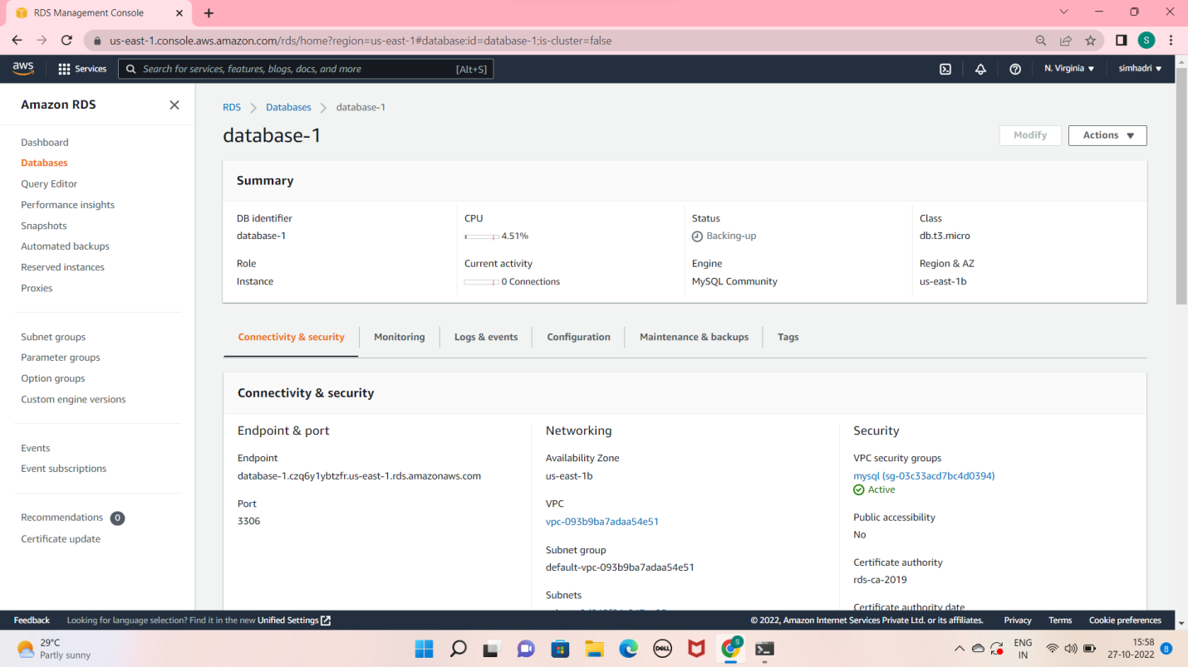

**Access this RDS from your EC2 instance**

**if we want to access rds from ec2 we have to install mysql in ec2 first then connect with rds endpoint**

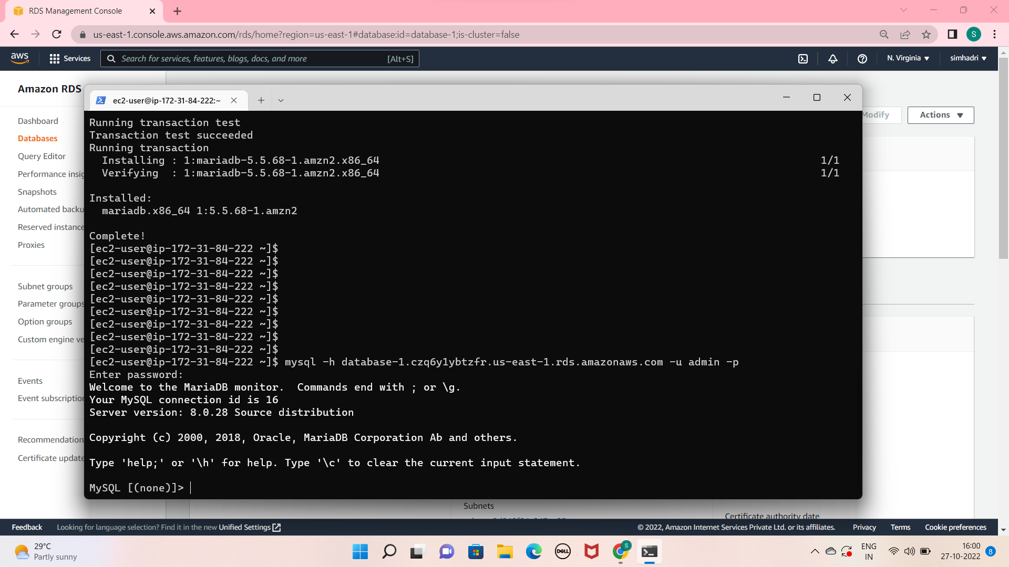

THANK YOU

K.RAMANA